Student Name | Shahid Azam
Student Number | 251606214
Subject | Advanced Data Visualization
Title | A Comparative Machine Learning Framework for Heart Attack Risk Prediction Using Data Preprocessing, Class Imbalance Handling, and Cross-Validation
Collaborator | Dr. Muhammad Sajjad
Submission Date | 06/28/2026

1: Problem Statement
Heart attack is a leading global health problem, responsible for millions of deaths each year, and its rising prevalence highlights the urgent need for preventive healthcare worldwide. It is also known as a myocardial infarction, occurs when the blood supply to a part of the heart muscle becomes blocked, which happens due to the build-up of fatty deposits including cholesterol that form plagues in the coronary arteries (Solanki and Sharma, 2019). The risk of heart attack increases with age, especially in men over 45 and women over 55 (Cushman et al., 2021). Men are generally at higher risk, although women’s risk increases significantly after menopause (Nappi et al., 2022). High blood pressure is one of the most significant contributors, as it forces the heart to work harder, damaging arteries over time (Magder, 2019). High levels of LDL cholesterol, or "bad" cholesterol, can lead to plaque formation in the arteries, while low levels of HDL, or "good" cholesterol, reduce the body's ability to clear cholesterol from the bloodstream (Upadhyay, 2023). Assessing the risk of heart attack is crucial because early identification and management of contributing factors can significantly reduce mortality and improve long-term cardiovascular health, which is essential to develop effective strategies, reduce the global burden of cardiovascular disease, and improve early diagnosis and treatment outcomes for at-risk populations.
The research problem arises from the increasing global prevalence of cardiovascular diseases and the complexity of factors that contribute to heart attack that makes early prediction and prevention difficult. Although studies have identified individual risk factors such as high blood pressure, diabetes, high cholesterol, smoking, obesity, and sedentary lifestyle, but there is still a lack of integrated models that combine clinical, demographic, and biochemical factors to accurately predict heart attack risks. The current study aims to address the gap in existing studies by integrating multiple risk factors into a single predictive framework and by comparing different machine learning algorithms to determine the most effective method for heart attack risk prediction. By doing so, the study seeks to contribute to early diagnostic, better risk assessment, and improved prevention strategies that can ultimately reduce the mortality and morbidity associated with heart attacks.

2: Dataset Collection & Preprocessing
To meet the research problem, current study relied on quantitative research design to study the determinants of heart attack using advanced machine learning methods. The central objective ot model heart attack occurrence as a binary dependent variable and to identify most significant contributor factors through the application of statistical machine learning methods using SPSS. The dataset used in the current study obtained from Kaggle using https://www.kaggle.com/datasets/ghnshymsaini/heart-attack-risk-prediction-dataset. The dependent variable is heart attack risk coded as binary variable (1=present of heart attack risk, and 0=absence). Independent variables include age (continuous variable), sex (binary), total cholesterol, systolic bp, diastolic bp (continuous variables), smoking habit, and diabetes (binary numbers).
Initially, the dataset was examined for missing values, duplicate records, inconsistencies, and outliers using descriptive statistics to ensure data quality and suitability for predictive modelling. Relevant features were then selected to improve model effectiveness, while class imbalance was addressed using the Synthetic Minority Oversampling Technique (SMOTE) and class weighting to enhance the identification of heart attack cases. The dataset was divided into training and testing subsets using an 80:20 ratio, and five-fold cross-validation was employed to improve model generalizability and reduce overfitting. Six supervised machine learning algorithms—Logistic Regression, Random Forest, Gradient Boosting, LightGBM, AdaBoost, and Multi-Layer Perceptron (MLP) Neural Network—were comparatively evaluated following hyperparameter optimization. Model performance was assessed using accuracy, precision, recall, F1-score, balanced accuracy, ROC-AUC, and confusion matrices, while all preprocessing, model development, optimization, and evaluation procedures were implemented in Python using established scientific computing and machine learning libraries.

3: Proposed Solution
The proposed solution involves a comprehensive machine learning pipeline designed to predict heart attack risk and identify the most influential cardiovascular risk factors. The process begins with data acquisition from the Kaggle Heart Attack Risk Prediction Dataset, followed by data cleaning, handling missing values, and encoding categorical variables such as sex, smoking habit, and diabetes status into binary numerical formats. Continuous variables including age, total cholesterol, systolic blood pressure, and diastolic blood pressure are standardized to improve model performance. The prepared dataset is then divided into training (70%) and testing (30%) subsets. Multiple machine learning algorithms including Binary Logistic Regression, Decision Tree (CART), Artificial Neural Network (Multilayer Perceptron), and K-Means Clustering are applied to analyze both linear and non-linear relationships. Model performance is evaluated using accuracy and sensitivity metrics, allowing comparison of predictive capabilities and identification of the most reliable model for heart attack risk prediction.
During preprocessing, missing value patterns and feature scaling effects are presented through graphical representations to ensure data quality and model readiness. These visualizations provide valuable insights into data characteristics and assist in selecting appropriate machine learning techniques. Since the current study already employs Artificial Neural Networks, transfer learning can be incorporated by adapting a pre-trained cardiovascular disease prediction model and retraining it using the heart attack risk dataset. The performance of the transfer learning model can then be compared with the logistic regression, decision tree, and neural network models to determine whether previously learned medical knowledge improves prediction accuracy and sensitivity.

4: Experimental Setup
The experimental setup was designed to ensure a fair and systematic comparison of multiple machine learning algorithms for heart attack risk prediction. Following data preprocessing, feature selection, and class imbalance handling using the Synthetic Minority Oversampling Technique (SMOTE), the dataset was divided into training and testing subsets using an 80:20 ratio. The training dataset was used to develop and optimize the prediction models, while the testing dataset was reserved for evaluating model performance on previously unseen data. Five-fold cross-validation was performed during model training to improve model robustness, reduce overfitting, and obtain reliable estimates of predictive performance. Hyperparameter optimization was conducted for each algorithm to identify appropriate parameter settings before final model evaluation. Six supervised machine learning algorithms, namely Logistic Regression, Random Forest, Gradient Boosting, LightGBM, AdaBoost, and Multi-Layer Perceptron (MLP) Neural Network, were implemented and comparatively evaluated using Python and established machine learning libraries. The predictive performance of each model was assessed using accuracy, precision, recall, F1-score, balanced accuracy, ROC-AUC, and confusion matrix analysis to provide a comprehensive evaluation of classification effectiveness.

5: Analysis Report
Before moving to inferential and advanced machine learning models; researcher carried basic descriptive analysis to check the demographic features. The results are presented in below table;
Table 1: Differences between Individual’s with and Without Heart Attack
Heart Attack | Heart Attack Absence |  |  |  | Heart Attack Presence
 | Mean | N | Std. Dev | Range | Mean | N | Std. Dev | Range
Total Cholesterol | 198.68 | 896 | 39.55 | 270.49 | 221.869 | 104 | 38.39 | 227.88
Systolic bp | 119.39 | 896 | 15.21 | 89.65 | 128.246 | 104 | 15.88 | 73.95
Diastolic bp | 79.62 | 896 | 10.11 | 64.55 | 85.469 | 104 | 9.84 | 46.61
From Table 1; for total cholesterol, the mean value is substantially higher among those with heart attack presence (221.87) compared to absence (198.68), suggesting a strong association with increased risk. Similarly, systolic blood pressure is higher in the presence group (128.25) than in the absence group (119.39), and diastolic blood pressure follows the same pattern, with means of 85.47 and 79.62 respectively. The standard deviations are relatively similar across groups, indicating comparable variability, while the ranges show slightly wider dispersion in the absence group for cholesterol (270.49 vs. 227.88) but not for blood pressure measures.
Table 2: Heart Attack Distribution Across Demographics
Factors | Demographic | Heart Attack
 |  | Present | Absent | Total
Sex | Male | 72 | 455 | 527
 | Female | 441 | 32 | 473
Smoking | Yes | 47 | 155 | 202
 | No | 57 | 741 | 798
Diabetes | Yes | 35 | 55 | 90
 | No | 69 | 841 | 910
Researcher carried balanced class distribution with the aim to prevents models from becoming biased toward one lass. Since both classes were represented equally, the algorithm was provided with sufficient information to learn patterns associated with both heart attack and non-heart attack outcomes. Such a distribution generally contributes to more reliable and unbiased classification performance. The results are presented in Figure 1.
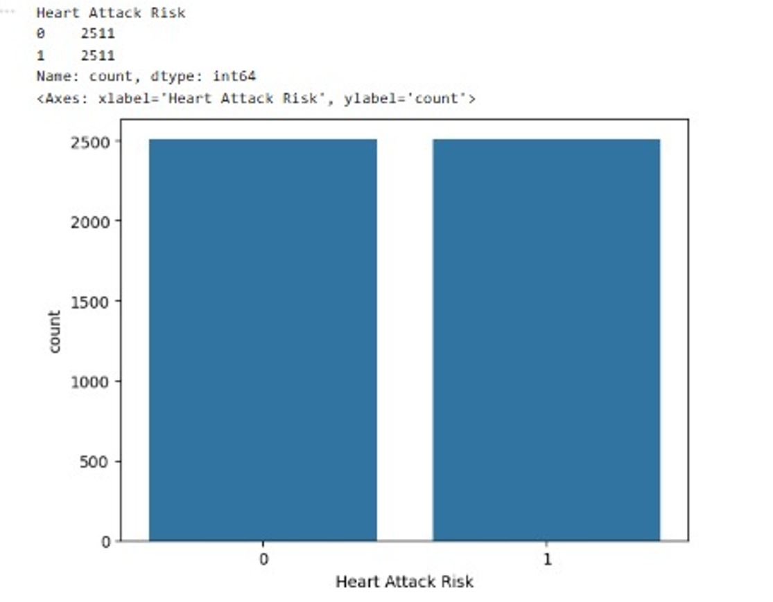
Figure 1: Class Distribution
The figure presents the original distribution of the target variable before applying any balancing technique. The dataset contained an equal representation of both classes, with 2,511 observations belonging to the non-heart attack category and 2,511 observations belonging to the heart attack category, which indicates a perfectly balanced dataset in which each class accounted for 50% of the total observations. The balanced distribution achieved through SMOTE helped ensure that machine learning algorithms received an equal number of examples from each class. This is particularly important in healthcare prediction because minority cases often represent the most clinically significant outcomes. Results are presented in Figure 2.
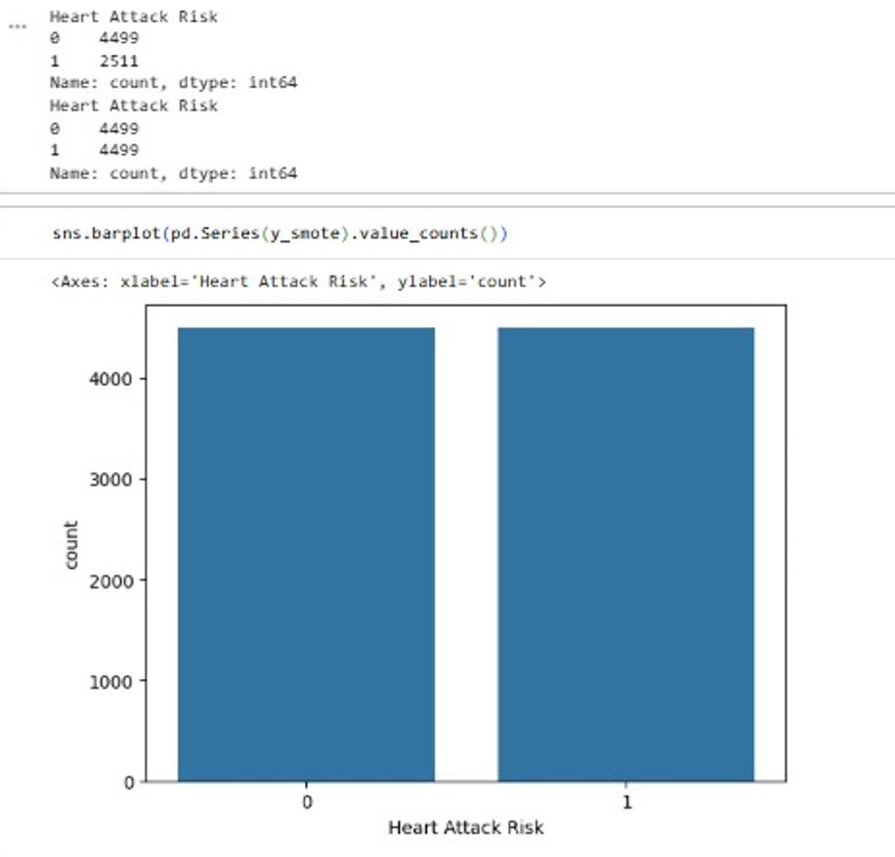
Figure 2: Class Distribution After Applying SMOTE
Figure 2 illustrates the class distribution after applying to the Synthetic Minority Oversampling Technique (SMOTE). Following oversampling, both classes contained 4,499 observations, resulting in an equal distribution of heart attack and non-heart attack cases. The balancing process successfully increased the representation of the minority class and produced a larger dataset for model training.
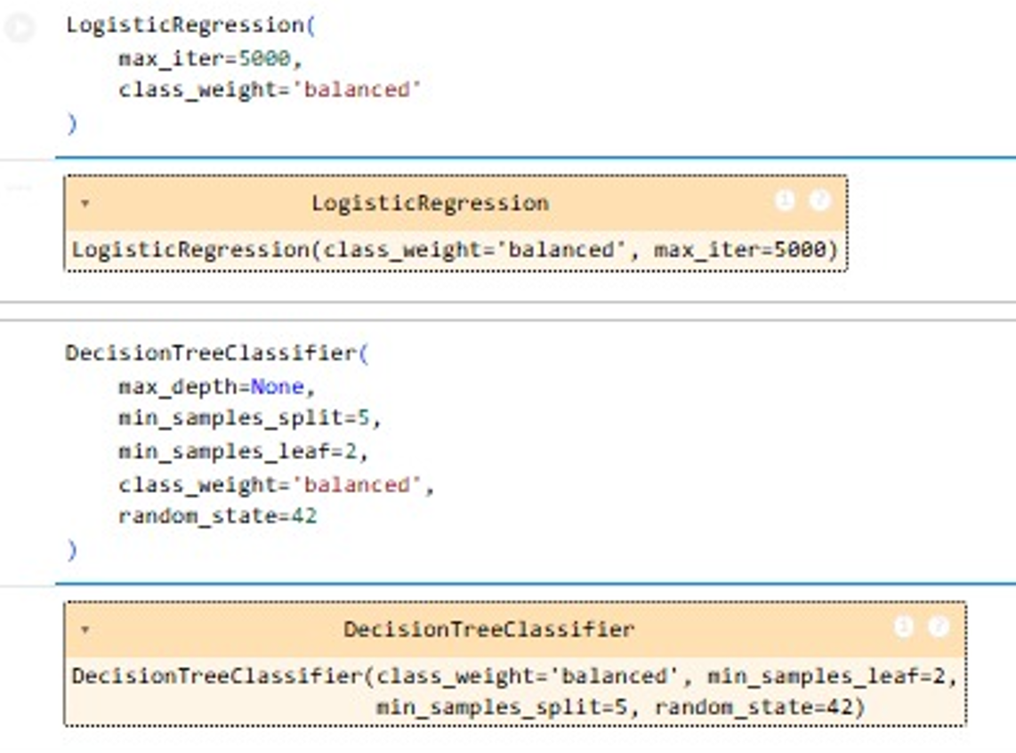
Figure 3: Machine Learning Model Configuration
Figure 3 presents the configuration settings for Logistic Regression and Decision Tree models. Logistic Regression was implemented using balanced class weights and an increased iteration limit of 5,000 to ensure convergence during training. Similarly, the Decision Tree model incorporated balanced class weights and additional parameters to control model complexity and reduce overfitting.
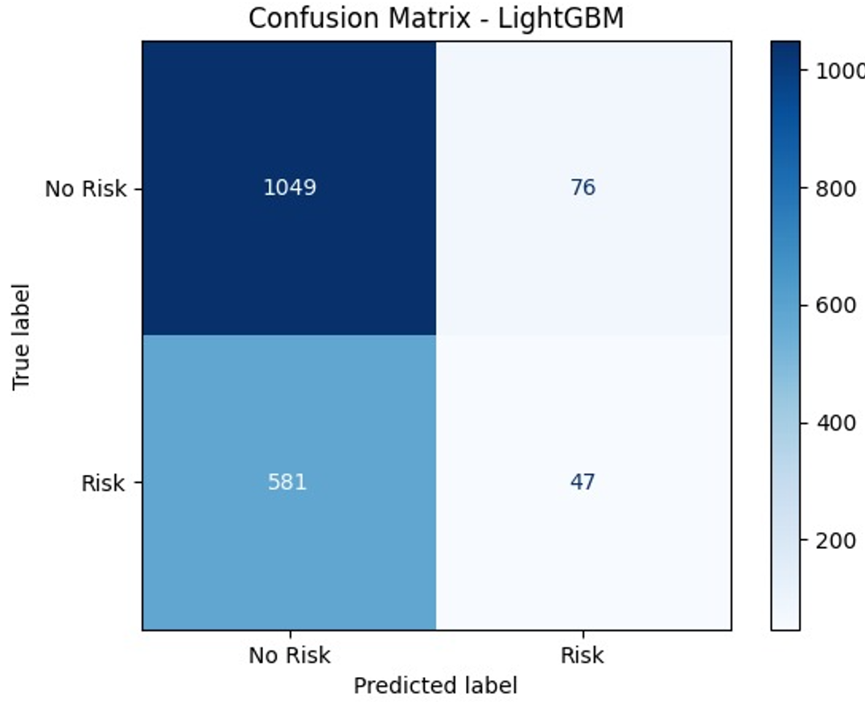
Figure 4: Confusion Matrix of Light GBM
From Figure 3, model correctly classified 1,049 non-risk cases and 47 risk cases. However, it incorrectly classified 76 non-risk cases as risk and 581 risk cases as non-risk. This indicates that the model performed well in identifying non-risk individuals but struggled to detect a large proportion of actual risk cases.
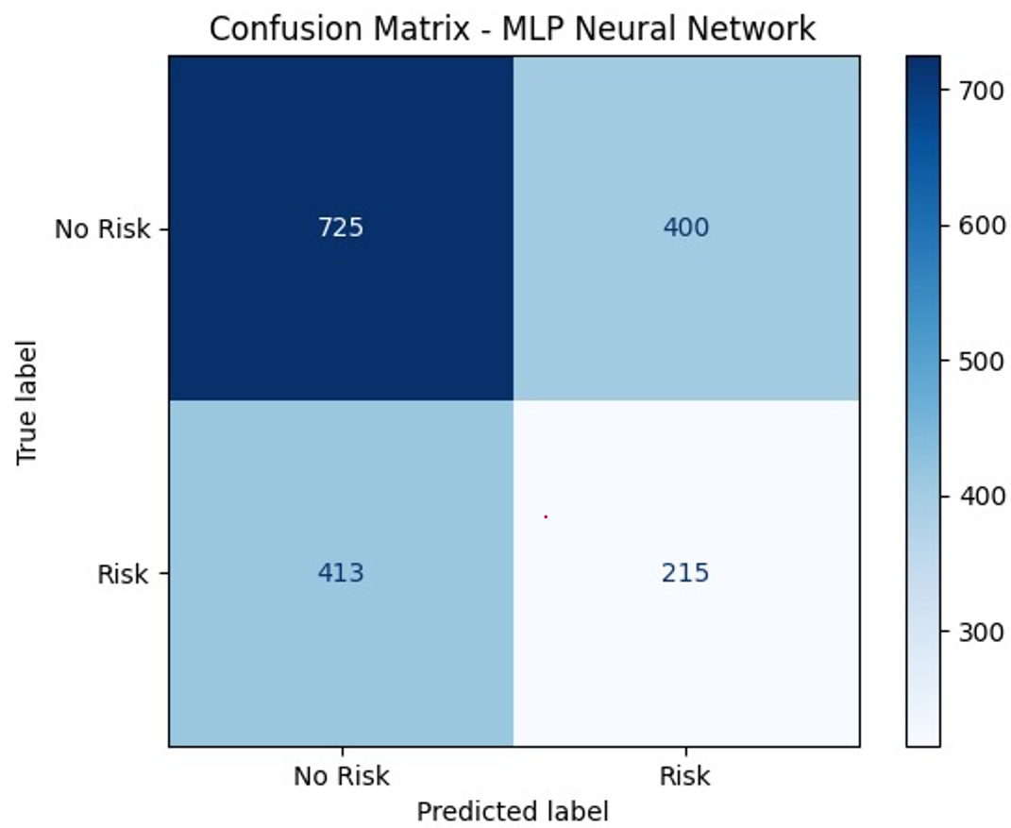
Figure 5: Confusion Matrix: MLP Neural Network
The confusion matrix illustrates the performance of the Multi-Layer Perceptron Neural Network. The model correctly identified 725 non-risk cases and 215 risk cases. At the same time, it misclassified 400 non-risk cases as risk and 413 risk cases as non-risk. Compared with LightGBM, the MLP Neural Network detected substantially more heart attack cases, correctly identifying 215 risk cases compared with only 47 identified by LightGBM. Although the number of false positives increased, the improved detection of actual heart attack cases suggests that the neural network demonstrated stronger sensitivity and greater potential for healthcare screening applications.
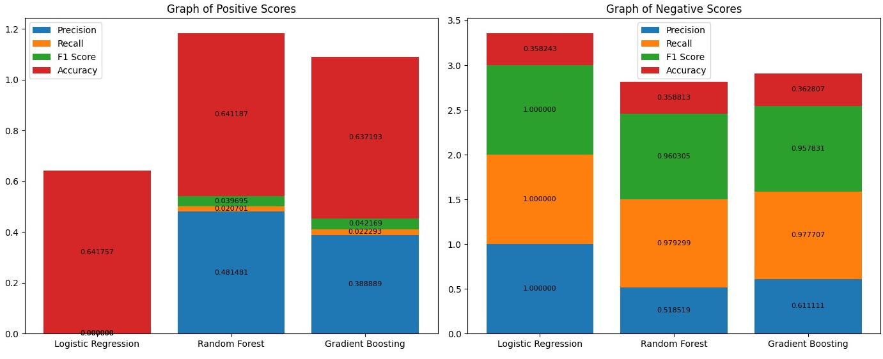
Figure 6: Positive and Negative Performance Score
Figure 6 compares precision, recall, F1-score, and accuracy for Logistic Regression, Random Forest, and Gradient Boosting models. For positive class prediction, Random Forest achieved the highest accuracy of approximately 0.643 and precision of approximately 0.494. Gradient Boosting produced similar results with an accuracy of approximately 0.638 and precision of approximately 0.389. Logistic Regression demonstrated comparatively lower values across most performance indicators. For negative class prediction, Logistic Regression achieved perfect precision and recall values of 1.000, indicating strong identification of negative cases. However, Random Forest and Gradient Boosting provided a more balanced performance across positive and negative classifications suggesting that ensemble models may offer greater overall predictive stability than Logistic Regression.
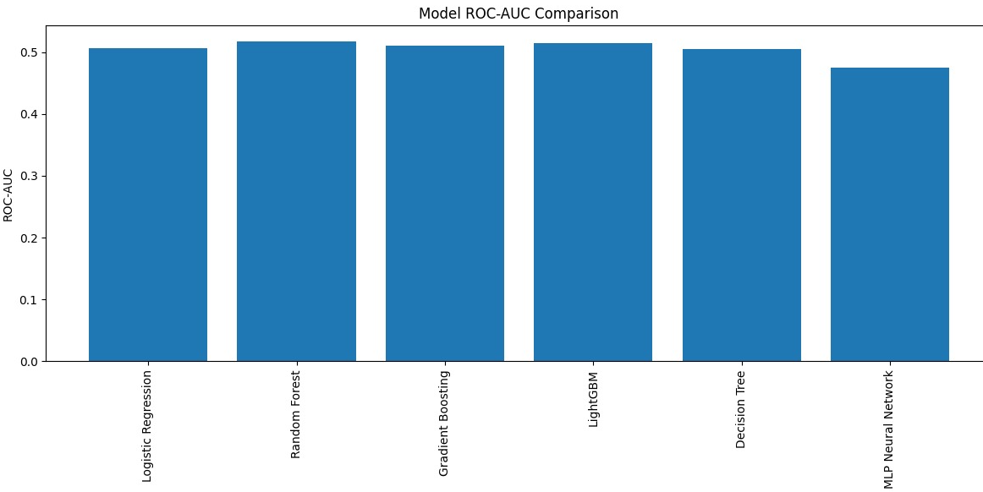
Figure 7: ROC-AUC Comparison
From Figure 7; Random Forest achieved the highest ROC-AUC value of approximately 0.52, followed closely by LightGBM and Gradient Boosting, each near 0.51. Logistic Regression and Decision Tree produced ROC-AUC values around 0.50, while the MLP Neural Network recorded the lowest value at approximately 0.47. The results indicate that all models demonstrated limited discriminative capability, with ROC-AUC values remaining close to 0.50. Since a value of 0.50 represents random classification, the findings suggest that none of the models achieved strong separation between heart attack and non-heart attack cases.
Figure 8presents the F1-score comparison among the evaluated models. Decision Tree achieved the highest F1-score of approximately 0.37, followed closely by the MLP Neural Network with a value of approximately 0.34. LightGBM produced a moderate F1-score of approximately 0.12, whereas Logistic Regression, Random Forest, and Gradient Boosting generated substantially lower values below 0.05. These findings indicate that Decision Tree and MLP provided the best balance between precision and recall. Since the F1-score simultaneously considers both metrics, higher values suggest stronger overall classification performance, particularly in identifying heart attack cases within the dataset.
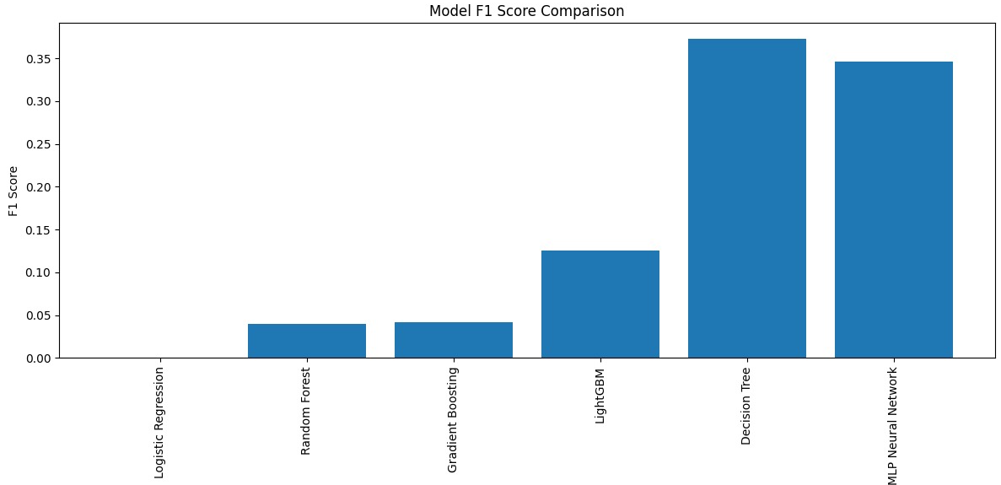
Figure 8: F1-Score Comparison
Logistic Regression and Random Forest achieved the highest accuracy of approximately 0.64, followed closely by Gradient Boosting at approximately 0.63. LightGBM produced an accuracy of approximately 0.62, while Decision Tree and MLP Neural Network achieved approximately 0.54. Although Logistic Regression and Random Forest recorded the highest accuracy values, accuracy alone does not provide a complete assessment of performance. Given the healthcare context, models with lower accuracy but higher sensitivity may be more valuable because they improve the identification of patients at risk of heart attack. The results of model accuracy is presented in Figure 9.
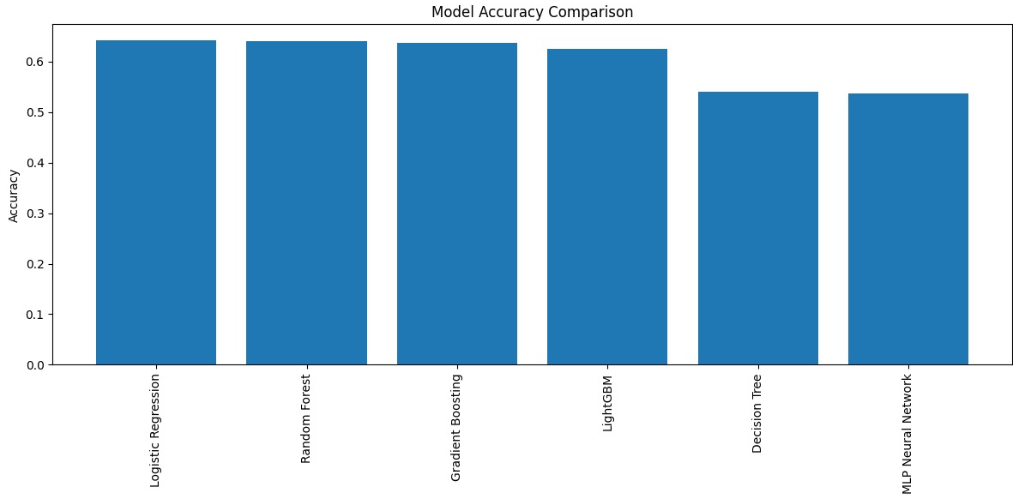
Figure 9: Model Accuracy Comparison
The cross-validation metrics in Figure 10 show that Accuracy achieved the highest value at approximately 0.60, followed by precision at approximately 0.35. Recall reached approximately 0.13, while the F1-score was approximately 0.19.
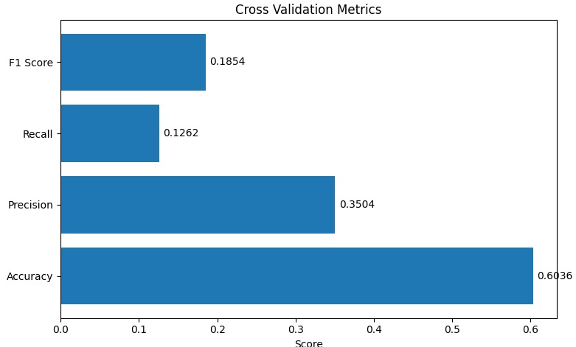
Figure 10: Cross-Validation Metrics
Figure 11 summarizes the overall performance of all tuned machine learning models. Logistic Regression and Random Forest achieved the highest accuracy values of approximately 0.64, while Gradient Boosting and LightGBM followed closely with values above 0.62. Decision Tree and MLP Neural Network produced lower accuracy values of approximately 0.54. In terms of balanced performance, Decision Tree and MLP Neural Network demonstrated higher recall and F1-scores than the other models. This indicates that although they achieved lower overall accuracy, they were more effective in identifying actual heart attack cases. Consequently, Decision Tree and MLP may offer greater clinical utility, whereas Logistic Regression and Random Forest provide stronger overall classification accuracy.
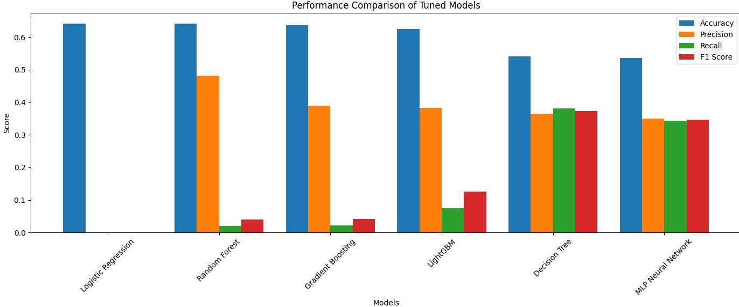
Figure 11: Performance Comparison of Tuned Models
Based on the findings of current study, the comparative evaluation of six machine learning algorithms demonstrated varying levels of effectiveness for heart attack risk prediction. Logistic Regression and Random Forest achieved the highest overall accuracy of approximately 64%, followed closely by Gradient Boosting (63%) and LightGBM (62%), while Decision Tree and Multi-Layer Perceptron (MLP) achieved approximately 54% accuracy. Despite their relatively lower overall accuracy, Decision Tree and MLP exhibited improved detection of heart attack cases, producing higher F1-scores of approximately 0.37 and 0.34, respectively, indicating a better balance between precision and recall. The LightGBM confusion matrix showed 1,049 true negatives, 47 true positives, 76 false positives, and 581 false negatives, highlighting its strong ability to classify non-heart attack cases but limited sensitivity in identifying patients at risk. In comparison, the MLP model correctly identified 215 heart attack cases and 725 non-heart attack cases, demonstrating considerably better sensitivity than LightGBM despite generating more false-positive predictions. Cross-validation further indicated an average accuracy of approximately 60%, precision of 35%, recall of 13%, and F1-score of 19%, suggesting moderate model generalizability across validation folds. Overall, the findings indicate that while ensemble learning methods produced the highest overall classification accuracy, Decision Tree and MLP provided superior minority-class detection, emphasizing the importance of evaluating machine learning models using multiple performance metrics rather than clinically meaningful heart attack prediction.

5: Conclusion and Recommendations
The current study evaluated supervised learning machine algorithms to predict heart attack risk using a comprehensive machine learning framework incorporating data preprocessing, class imbalance handling, feature selection, and cross-validation. The comparative evaluation demonstrated that each algorithm exhibited distinct predictive characteristics confirming that no single machine learning model consistently outperformed the others across every evaluation criterion (Azdaki et al., 2024). The findings of current study indicated that ensemble learning algorithms generally provide superior overall classification performance, accuracy alone cannot be regarded as sufficient evidence of clinical usefulness because healthcare prediction requires effective identification of disease-positive cases rather than simply maximizing the number of correctly classified observations (Ilyas et al., 2019). The findings of current study reinforce existing evidence supporting the suitability of Random Forest for structured healthcare dataset containing multiple demographic and clinical variables. Gradient Boosting and LightGBM demonstrated competitive predictive performance producing overall accuracies, only slightly lower than Random Forest (Peng and Yu, 2023). These findings indicate that LightGBM is substantially more effective at recognizing healthy individuals than patients at elevated cardiovascular risk. The findings from MLP Neural Network provide an interesting contrast to those produced by the ensemble learning algorithms as it demonstrated substantially stronger ability to detect heart attack cases (Rawat et al., 2021). Confusion matrix indicated that the neural network correctly identified 215 positive cases compared to only 47 identified in LightGBM illustrating that the well-established trade-off between sensitivity and specificity frequently observed in medical machine learning applications.
The comparative evaluation of the machine learning models demonstrated that relying solely on overall accuracy does not provide a comprehensive understanding of predictive performance in healthcare applications. The comparison of F1-scores demonstrated that the Decision Tree achieved the highest value of approximately 0.37 followed closely by the MLP with an F1-Score of approximately 0.34. However, Logistic Regression, Random Forest, Gradient Boosting, and LightGBM have recorded lower F1-Score despite their relatively higher classification accuracy. Cross-validation results demonstrated an average recall of approximately 13% indicating that the models correctly identified only a limited proportion of positive heart attack cases across different validation folds. Precision values obtained during cross-validation averaged approximately 35%, indicating that approximately one-third of positive predictions corresponded to actual heart attack cases. The findings showed that Random Forest achieved the highest ROC-AUC value of approximately 52% followed closely by Gradient Boosting and LightGBM whereas MLP recorded the lowest value of approximately 047. The findings demonstrate that preprocessing, class imbalance handling, and rigorous validation collectively improve the robustness and reliability of machine learning models supporting the adoption of integrated methodological frameworks within future healthcare analytics research.
From theoretical perspective, the current study contributes to the growing body of literature on AI and medical informatics by demonstrating that machine learning algorithms cannot be evaluated independently on the analytical framework within which they operate (Ilyas et al., 2019) The findings of current study reinforce the theoretical argument that predictive effectiveness depends upon both algorithms’ selection and methodological design rather than algorithms complexity alone. The current study demonstrates that systematic preprocessing procedures improve dataset quality and establish a more reliable foundation for predictive modeling highlighting that improvements in data quality frequently produce more substantial benefits than introducing complex prediction algorithms (Abbott et al., 2002). The incorporation of SMOTE together with balanced class weighting within the current study demonstrates a practical strategy for reducing prediction bias and improving minority class representation during model training. The use of multiple evaluation metrics provides more meaningful information regarding model behavior and supports more informed selection of machine learning algorithms for healthcare applications (Liu et al., 2012). The comparative machine learning framework in the current study provides a structured methodology that hospitals can adopt when developing predictive analytics systems for cardiovascular diseases management. Rather than implementing machine learning algorithms without systematic evaluation, healthcare organizations can utilize comprehensive preprocessing procedures, balanced learning techniques, cross-validation, and multiple performance measures to identify models most appropriate for their specific patient populations (Ripan et al., 2021).
Although the dataset contains sufficient observation to compare multiple machine learning algorithms, it may not fully represent the diversity of heart attack patients encountered in different healthcare settings. The absence of additional factors such as physical activity, generic information, psychological stress, etc. may have limited the ability of machine learning models to capture the complete complexity of heart attack risk. Moreover, the current study incorporated SMOTE and balanced class weighting to reduce prediction bias, the minority class remained challenging to predict accurately. Addressing these issues in future studies will contribute to the development of more accurate, reliable, and clinically applicable cardiovascular prediction systems.

References
Abbott, R. D., Curb, J. D., Rodriguez, B. L., Masaki, K. H., Yano, K., Schatz, I. J., ... & Petrovitch, H. (2002). Age-related changes in risk factor effects on the incidence of coronary heart disease. Annals of epidemiology, 12(3), 173-181.
Al Bashish, D., Braik, M., & Bani-Ahmad, S. (2011). Detection and classification of leaf diseases using K-means-based segmentation and. Information technology journal, 10(2), 267-275.
Alkayyali, Z. K., Idris, S. A. B., & Abu-Naser, S. S. (2025, January). Comparative Analysis of Regressor Models for Predicting Heart Attack Risk: A Comprehensive Evaluation Using Regression Metrics and Visualization. In Proceedings of Eighth International Conference on Information System Design and Intelligent Applications (pp. 119-132). Singapore: Springer Nature Singapore.
Azdaki, N., Salmani, F., Kazemi, T., Partovi, N., Bizhaem, S. K., Moghadam, M. N., ... & Khazdair, M. R. (2024). Which risk factor best predicts coronary artery disease using artificial neural network method?. BMC Medical Informatics and Decision Making, 24(1), 52.
Baghdadi, N. A., Farghaly Abdelaliem, S. M., Malki, A., Gad, I., Ewis, A., & Atlam, E. (2023). Advanced machine learning techniques for cardiovascular disease early detection and diagnosis. Journal of Big Data, 10(1), 144.
Banerjea, R., Sambamoorthi, U., Weaver, F., Maney, M., Pogach, L. M., & Findley, T. (2008). Risk of stroke, heart attack, and diabetes complications among veterans with spinal cord injury. Archives of physical medicine and rehabilitation, 89(8), 1448-1453.
Bhowmik, P. K., Miah, M. N. I., Uddin, M. K., Sizan, M. M. H., Pant, L., Islam, M. R., & Gurung, N. (2024). Advancing heart disease prediction through machine learning: techniques and insights for improved cardiovascular health. British Journal of Nursing Studies, 4(2), 35-50.
Cavender, M. A., Steg, P. G., Smith Jr, S. C., Eagle, K., Ohman, E. M., Goto, S., ... & Bhatt, D. L. (2015). Impact of diabetes mellitus on hospitalization for heart failure, cardiovascular events, and death: outcomes at 4 years from the Reduction of Atherothrombosis for Continued Health (REACH) Registry. Circulation, 132(10), 923-931.
Choi, Y. J., Park, J. S., Kim, U., Lee, S. H., Son, J. W., Shin, D. G., ... & Lee, J. H. (2013). Changes in smoking behavior and adherence to preventive guidelines among smokers after a heart attack. Journal of geriatric cardiology: JGC, 10(2), 146.
Cushman, M., Shay, C. M., Howard, V. J., Jiménez, M. C., Lewey, J., McSweeney, J. C., ... & American Heart Association. (2021). Ten-year differences in women’s awareness related to coronary heart disease: results of the 2019 American Heart Association National Survey: a special report from the American Heart Association. Circulation, 143(7), e239-e248.
Demir, S., Selvitopi, H., & Selvitopi, Z. (2025). An early and accurate diagnosis and detection of the coronary heart disease using deep learning and machine learning algorithms. Journal of Big Data, 12(1), 228.
Dileep, P., Rao, K. N., Bodapati, P., Gokuruboyina, S., Peddi, R., Grover, A., & Sheetal, A. (2023). An automatic heart disease prediction using cluster-based bi-directional LSTM (C-BiLSTM) algorithm. Neural Computing and Applications, 35(10), 7253-7266.
Flint, A. C., Conell, C., Ren, X., Banki, N. M., Chan, S. L., Rao, V. A., ... & Bhatt, D. L. (2019). Effect of systolic and diastolic blood pressure on cardiovascular outcomes. New England Journal of Medicine, 381(3), 243-251.
Gosmanova, E. O., Mikkelsen, M. K., Molnar, M. Z., Lu, J. L., Yessayan, L. T., Kalantar-Zadeh, K., & Kovesdy, C. P. (2016). Association of systolic blood pressure variability with mortality, coronary heart disease, stroke, and renal disease. Journal of the American College of Cardiology, 68(13), 1375-1386.
Haider, A. W., Larson, M. G., Franklin, S. S., & Levy, D. (2003). Systolic blood pressure, diastolic blood pressure, and pulse pressure as predictors of risk for congestive heart failure in the Framingham Heart Study. Annals of internal medicine, 138(1), 10-16.
Iliyas, M. M. K., Shaikh, M. I. S., & Student, M. (2019). Prediction of heart disease using decision tree. Allana Inst Manage Sci, Pune, 9, 1-5.
Kakadiya, J. (2009). Causes, symptoms, pathophysiology and diagnosis of atherosclerosis–a review. Pharmacologyonline, 3, 420-442.
Kannel, W. B., & Vokonas, P. S. (1992). Demographics of the prevalence, incidence, and management of coronary heart disease in the elderly and in women. Annals of Epidemiology, 2(1-2), 5-14.
Khamis, R. Y., Ammari, T., & Mikhail, G. W. (2016). Gender differences in coronary heart disease. Heart, 102(14), 1142-1149.
Khan, N. A., Rabkin, S. W., Zhao, Y., McAlister, F. A., Park, J. E., Guan, M., ... & Humphries, K. H. (2018). Effect of lowering diastolic pressure in patients with and without cardiovascular disease: analysis of the SPRINT (Systolic Blood Pressure Intervention Trial). Hypertension, 71(5), 840-847.
Khawla, R., Talukder, M. A., Layek, M. A., Das, U. K., Alazab, A., & Kazi, M. (2026). Enhanced cardiovascular disease risk prediction using explainable machine learning and data balancing. Discover Computing, 29(1), 100.
Leening, M. J., Ferket, B. S., Steyerberg, E. W., Kavousi, M., Deckers, J. W., Nieboer, D., ... & Roos-Hesselink, J. W. (2014). Sex differences in lifetime risk and first manifestation of cardiovascular disease: prospective population based cohort study. Bmj, 349.
Libby, P. (2002). Atherosclerosis: the new view. Scientific American, 286(5), 46-55.
Liu, K., Daviglus, M. L., Loria, C. M., Colangelo, L. A., Spring, B., Moller, A. C., & Lloyd-Jones, D. M. (2012). Healthy lifestyle through young adulthood and the presence of low cardiovascular disease risk profile in middle age: the Coronary Artery Risk Development in (Young) Adults (CARDIA) study. Circulation, 125(8), 996-1004.
Magder, S. (2018). The meaning of blood pressure. Critical Care, 22(1), 257.
Matheus, A. S. D. M., Tannus, L. R. M., Cobas, R. A., Palma, C. C. S., Negrato, C. A., & Gomes, M. D. B. (2013). Impact of diabetes on cardiovascular disease: an update. International journal of hypertension, 2013(1), 653789.
McEvoy, J. W., Chen, Y., Rawlings, A., Hoogeveen, R. C., Ballantyne, C. M., Blumenthal, R. S., ... & Selvin, E. (2016). Diastolic blood pressure, subclinical myocardial damage, and cardiac events: implications for blood pressure control. Journal of the American College of Cardiology, 68(16), 1713-1722.
Morrow, D. A. (2010). Cardiovascular risk prediction in patients with stable and unstable coronary heart disease. Circulation, 121(24), 2681-2691.
Nandal, N., Goel, L., & TANWAR, R. (2022). Machine learning-based heart attack prediction: A symptomatic heart attack prediction method and exploratory analysis. F1000Research, 11, 1126.
Nappi, R. E., Chedraui, P., Lambrinoudaki, I., & Simoncini, T. (2022). Menopause: a cardiometabolic transition. The lancet Diabetes & endocrinology, 10(6), 442-456.
Naser, M. A., Majeed, A. A., Alsabah, M., Al-Shaikhli, T. R., & Kaky, K. M. (2024). A review of machine learning’s role in cardiovascular disease prediction: recent advances and future challenges. Algorithms, 17(2), 78.
Nielson, C., & Lange, T. (2005). Blood glucose and heart failure in nondiabetic patients. Diabetes Care, 28(3), 607-611.
Peacock IV, W. F., De Marco, T., Fonarow, G. C., Diercks, D., Wynne, J., Apple, F. S., & Wu, A. H. (2008). Cardiac troponin and outcome in acute heart failure. New England Journal of Medicine, 358(20), 2117-2126.
Peng, K. G., & Yu, H. L. (2021). Characteristic analysis of clinical coronary heart disease and coronary artery disease concerning young and middle-aged male patients. World journal of clinical cases, 9(25), 7358.
Prati, F., Biccirè, F. G., Sammartini, E., & Gatto, L. (2024). Eliminate LDL cholesterol after heart attack… but only for a while. European Heart Journal Supplements, 26(Supplement_1), i99-i101.
Qiu, C., Afolabi, B. L., Deng, J., Su, K., Jiang, L., Gonzalez-Ramirez, M., ... & Deng, H. W. (2026). A Metabolomics-driven machine learning model for osteoporosis risk prediction. JBMR Plus, ziag042.
Rawat, A., Hivre, M., Sharma, A., Zaidi, S. A., Abedin, M. Z., & Hasan, M. H. (2023). Smoking And Coronary Heart Disease Impact. Journal of Pharmaceutical Negative Results, 2023, 1737-1742.
Razo, C., Welgan, C. A., Johnson, C. O., McLaughlin, S. A., Iannucci, V., Rodgers, A., ... & Roth, G. A. (2022). Effects of elevated systolic blood pressure on ischemic heart disease: a Burden of Proof study. Nature medicine, 28(10), 2056-2065.
Ripan, R. C., Sarker, I. H., Hossain, S. M. M., Anwar, M. M., Nowrozy, R., Hoque, M. M., & Furhad, M. H. (2021). A data-driven heart disease prediction model through K-means clustering-based anomaly detection. SN Computer Science, 2(2), 112.
Roeters van Lennep, J. E., Westerveld, H. T., Erkelens, D. W., & van der Wall, E. E. (2002). Risk factors for coronary heart disease: implications of gender. Cardiovascular research, 53(3), 538-549.
Rojek, I., Kotlarz, P., Kozielski, M., Jagodziński, M., & Królikowski, Z. (2024). Development of AI-based prediction of heart attack risk as an element of preventive medicine. Electronics, 13(2), 272.
Saboor, A., Usman, M., Ali, S., Samad, A., Abrar, M. F., & Ullah, N. (2022). A method for improving prediction of human heart disease using machine learning algorithms. Mobile Information Systems, 2022(1), 1410169.
Smiley, D. A., & Khalil, R. A. (2009). Estrogenic compounds, estrogen receptors and vascular cell signaling in the aging blood vessels. Current medicinal chemistry, 16(15), 1863-1887.
Smith, B. M., Criminisi, A., Sorek, N., Harari, Y., Sood, N., & Heymsfield, S. B. (2024). Modeling health risks using neural network ensembles. PLoS One, 19(10), e0308922.
Tromp, J., Paniagua, S. M., Lau, E. S., Allen, N. B., Blaha, M. J., Gansevoort, R. T., ... & Ho, J. E. (2021). Age dependent associations of risk factors with heart failure: pooled population based cohort study. bmj, 372.
Upadhyay, R. K. (2023). High cholesterol disorders, myocardial infarction and its therapeutics. World Journal of Cardiovascular Diseases, 13(8), 433-469.
Valavanis, I. K., Mougiakakou, S. G., Grimaldi, K. A., & Nikita, K. S. (2010). A multifactorial analysis of obesity as CVD risk factor: use of neural network based methods in a nutrigenetics context. BMC bioinformatics, 11(1), 453.
Wang, J., Rao, C., Goh, M., & Xiao, X. (2023). Risk assessment of coronary heart disease based on cloud-random forest. Artificial Intelligence Review, 56(1), 203-232.

